<https://etti.utcluj.ro/>

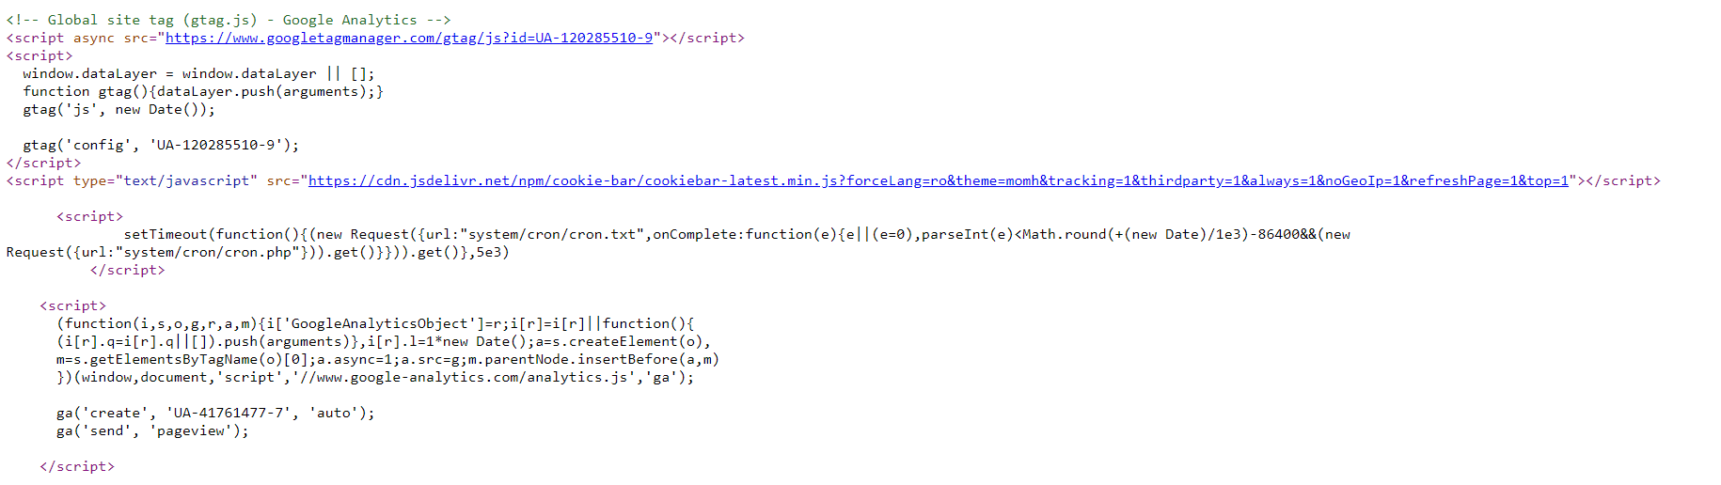java element: link

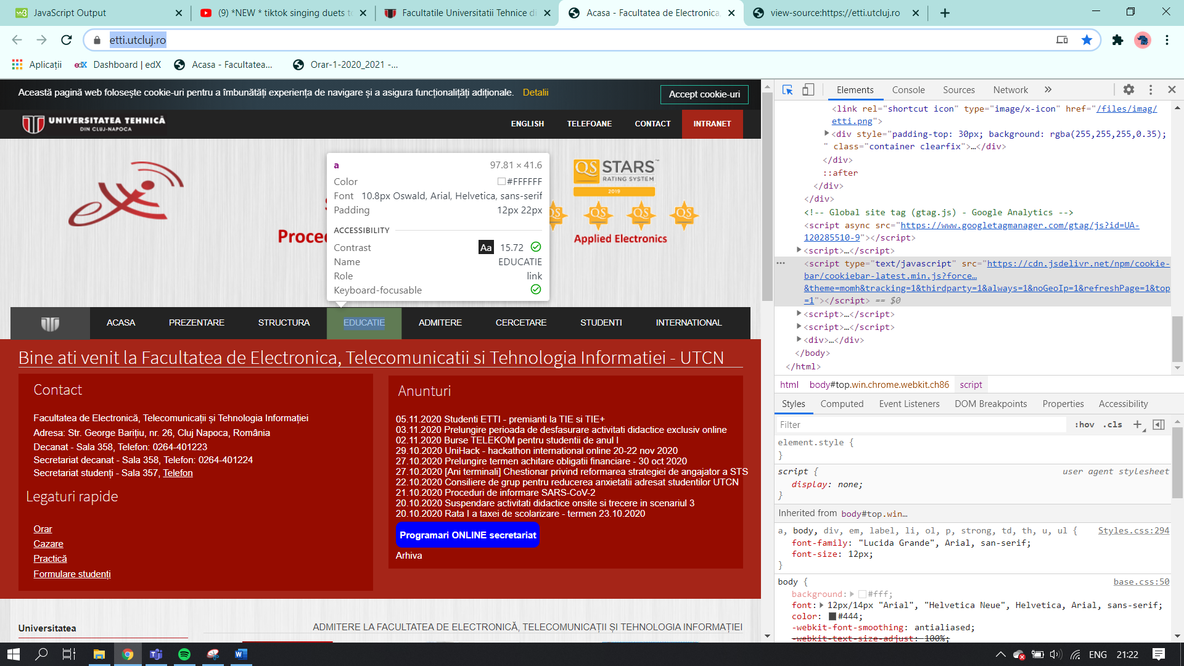

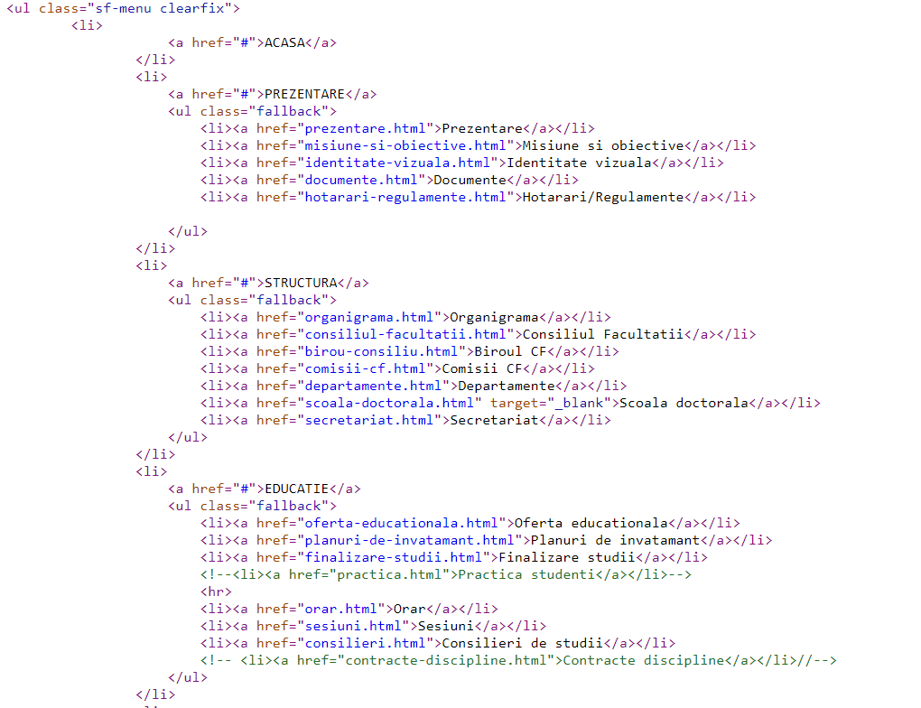LIATE DE TIP HTML

CSS

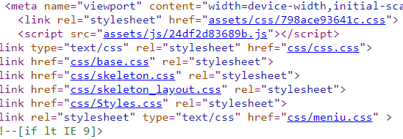DIFERITE LINKURI CATRE STYLESHEET-URI

